TC-DISP-025
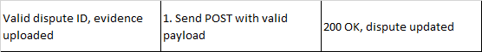
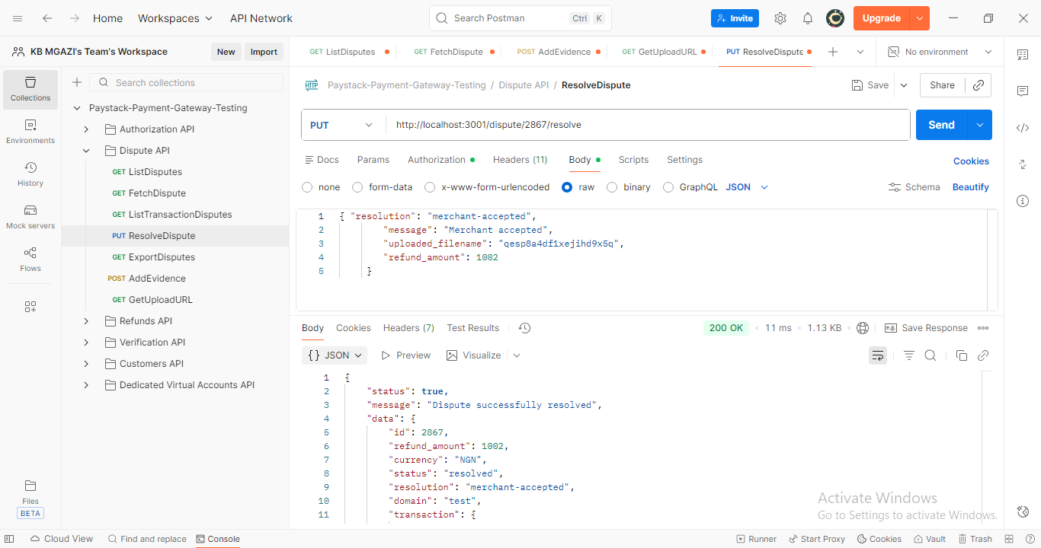
Request:
{
"resolution": "merchant-accepted",
"message": "Merchant accepted",
"uploaded_filename": "qesp8a4df1xejihd9x5q",
"refund_amount": 1002
}

Response:
{
"status": true,
"message": "Dispute successfully resolved",
"data": {
"id": 2867,
"refund_amount": 1002,
"currency": "NGN",
"status": "resolved",
"resolution": "merchant-accepted",
"domain": "test",
"transaction": {
"id": 2867,
"domain": "test",
"status": "success",
"reference": "asjck8gf76zd1dr",
"amount": 39100,
"gateway_response": "Successful",
"paid_at": "2017-11-09T00:01:56.000Z",
"created_at": "2017-11-09T00:01:36.000Z",
"channel": "card",
"currency": "ZAR",
"customer": {
"id": 10207,
"email": "shola@baddest.com"
}
},
"transaction_reference": null,
"customer": {
"id": 10207,
"email": "shola@baddest.com",
"customer_code": "CUS_unz4q52yjsd6064",
"risk_action": "default"
},
"history": [
{
"status": "pending",
"by": "demo@test.co",
"createdAt": "2017-11-16T16:12:24.000Z"
}
],
"messages": [
{
"sender": "demo@test.co",
"body": "test this",
"createdAt": "2017-11-16T16:12:24.000Z"
}
],
"createdAt": "2017-11-16T16:12:24.000Z",
"updatedAt": "2019-08-16T08:05:25.000Z",
"evidence": [],
"attachments": []
}
}

